Project Design Phase-II
Data Flow Diagram & User Stories

Date | 27-10-2026
Team ID
Project Name | StaffSync
Maximum Marks | 4 Marks

Data Flow Diagrams:
A Data Flow Diagram (DFD) illustrates how data moves within the StaffSync platform. It captures how users (HR, managers and employees) interact with the system, how information flows between different components, and where the data is stored.
Example: DFD Level 0 (Industry Standard)

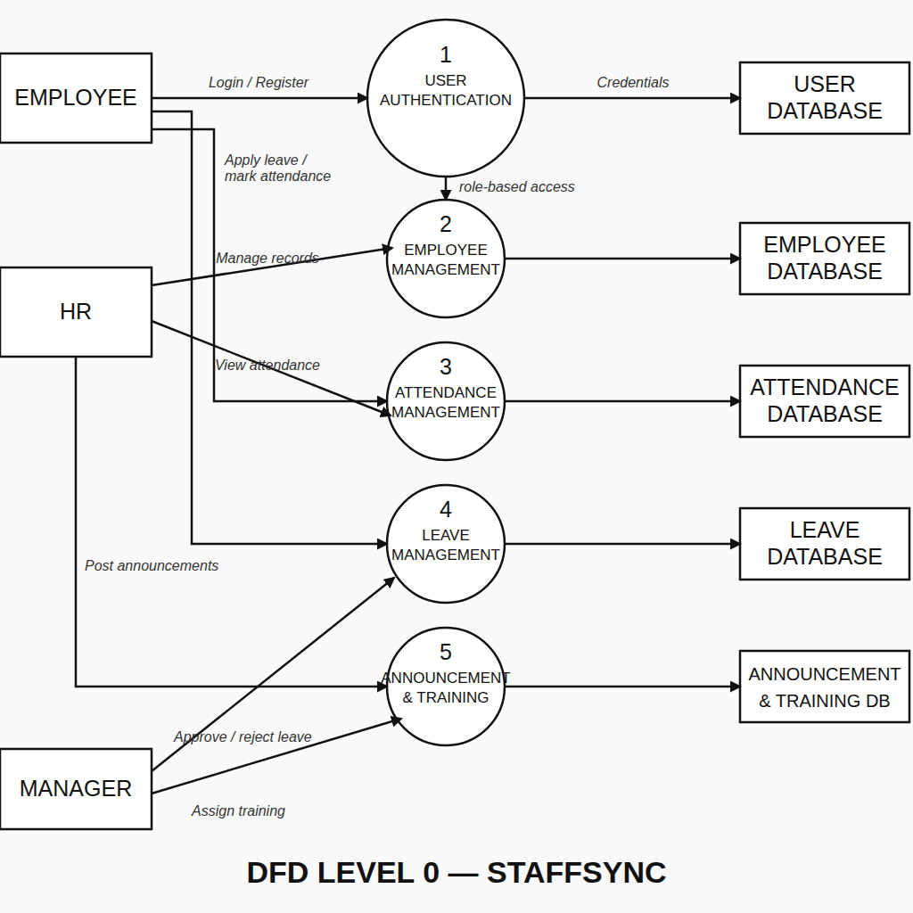

User Stories

User Story Table – StaffSync
User Type | Functional Requirement (Epic) | User Story / Task | Acceptance Criteria | Priority | Release
Employee |  | As an employee, I can register and log in securely. | JWT token is issued and I am redirected to my dashboard. | High | Sprint-1
  User Authentication
 |  | As an employee, I can mark my daily attendance. | Attendance is recorded and visible to HR. | High | Sprint-3
  Attendance Tracking
HR | Employee Management |  | Changes are saved and shown in the employee list. | High | Sprint-2
  As HR, I can add, edit, delete and view employee records.
Employee | Leave Application | As an employee, I can apply for leave and view its status. | Request reaches my manager and status updates. | High | Sprint-3
Manager | Leave Approval | As a manager, I can approve or reject leave requests. | Decision is saved and shown to the employee. | High | Sprint-3
HR | Announcements | As HR, I can post announcements for the organization. | Announcement is visible to all employees. | Medium | Sprint-4
Manager |  | As a manager, I can create and assign training programs. | Training appears on the employee page. | Medium | Sprint-4
  Training Management
HR | Reports & Analytics | As HR, I can view attendance and leave reports. | Reports show accurate records. | Medium | Sprint-4

